**Problem 1 - Array Merge**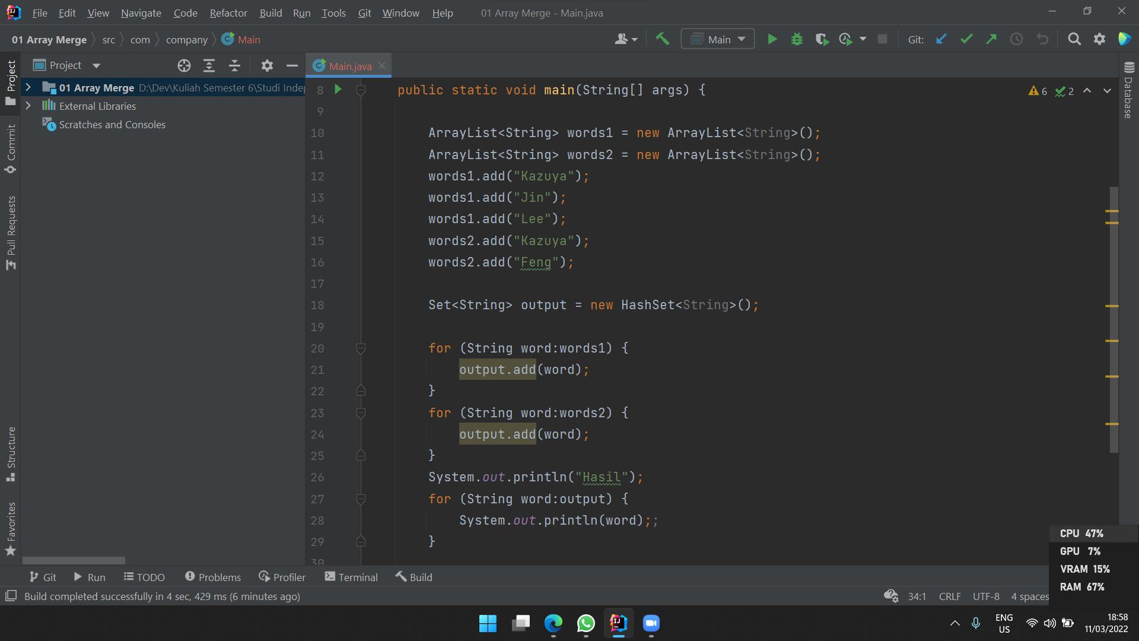

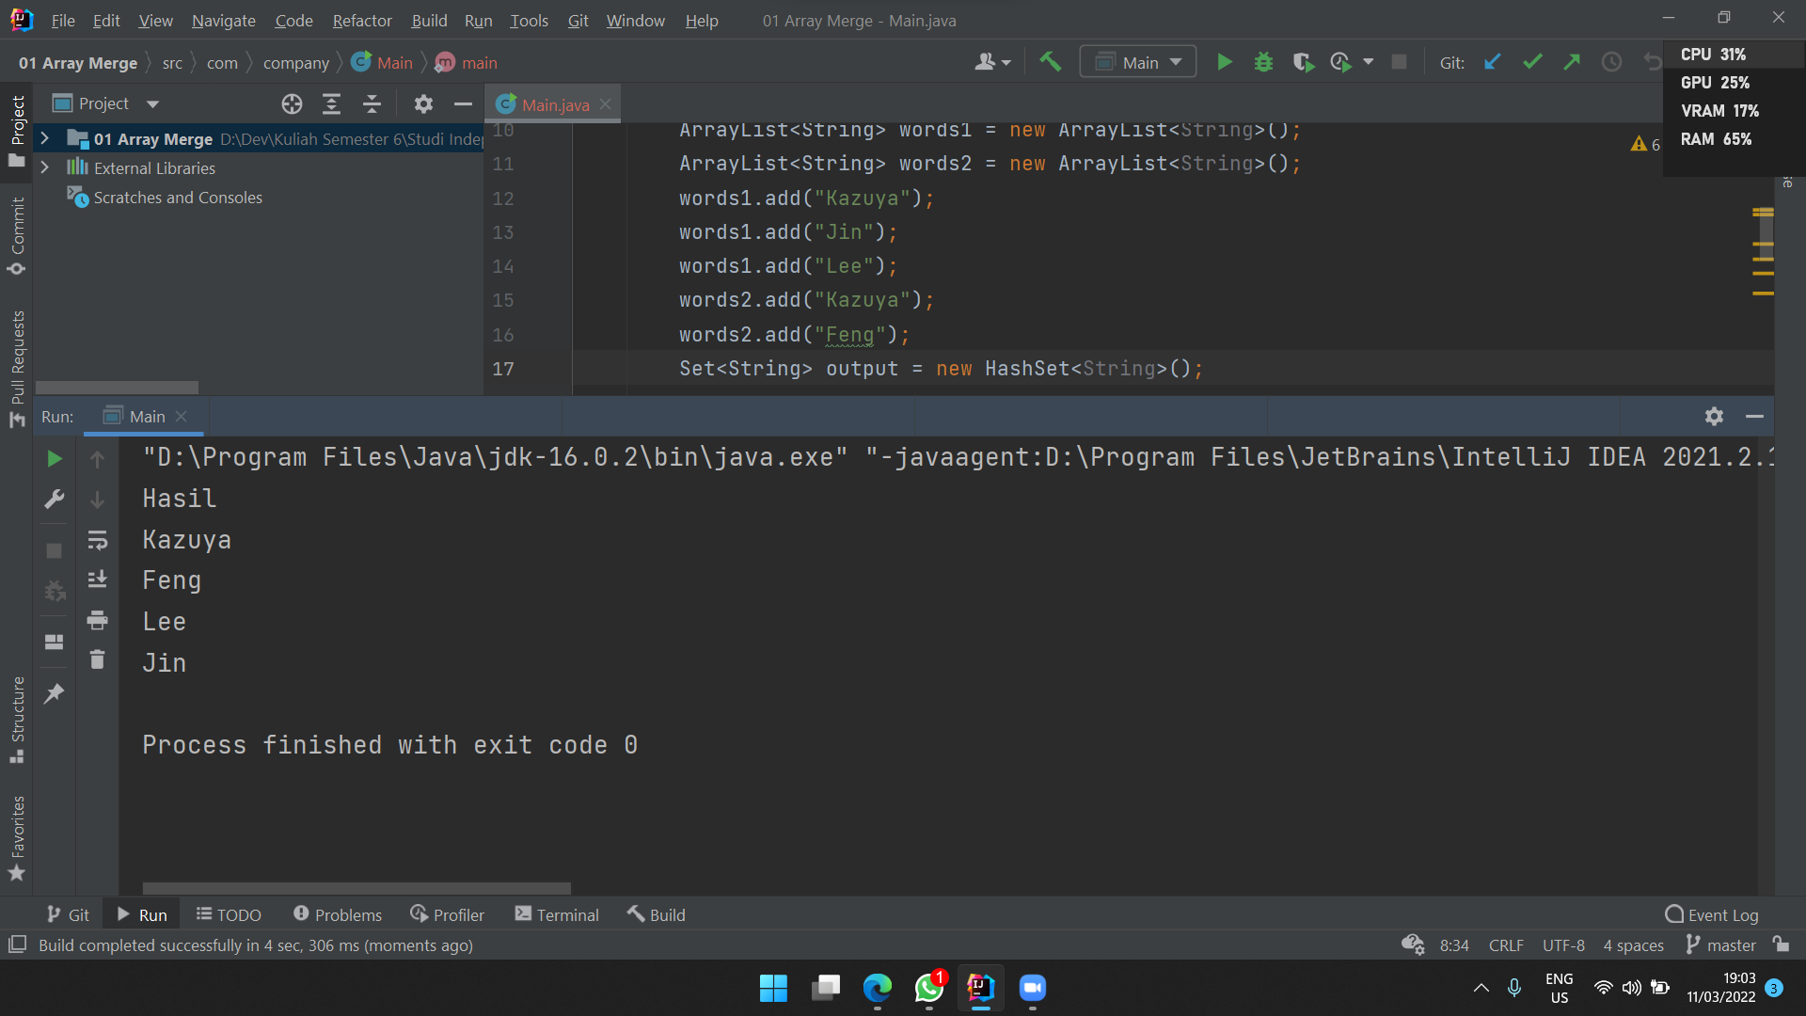

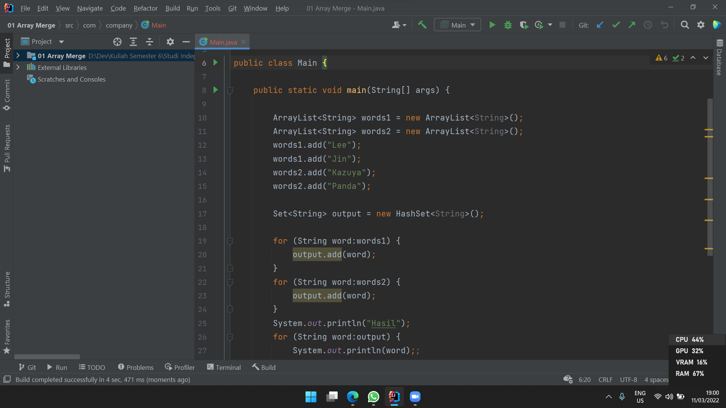

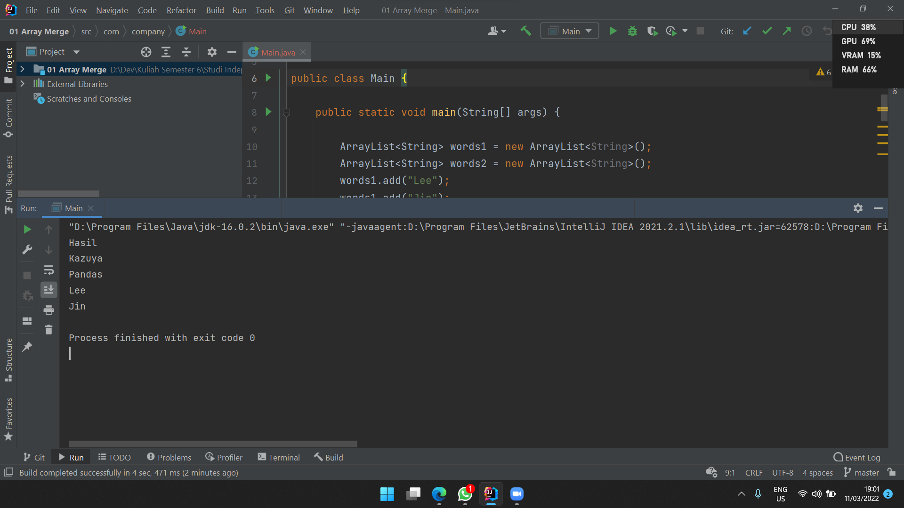

**Problem 2 - Array Merge**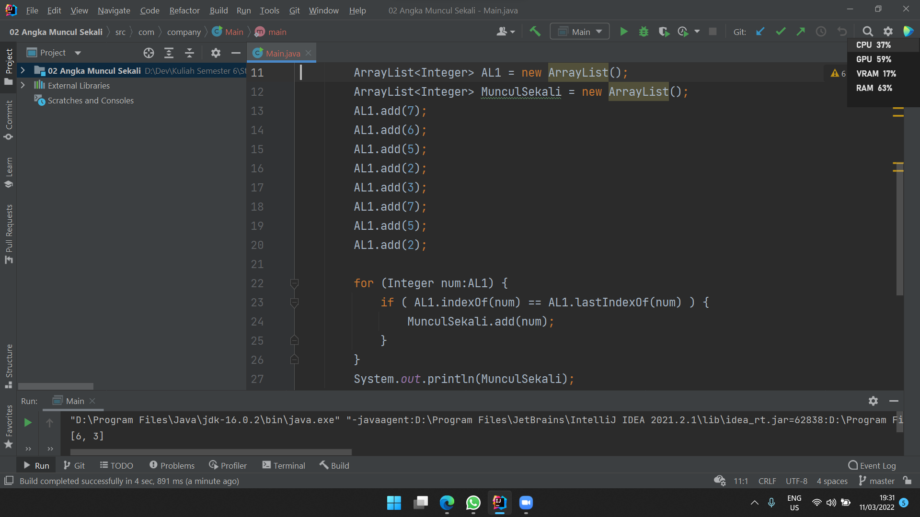

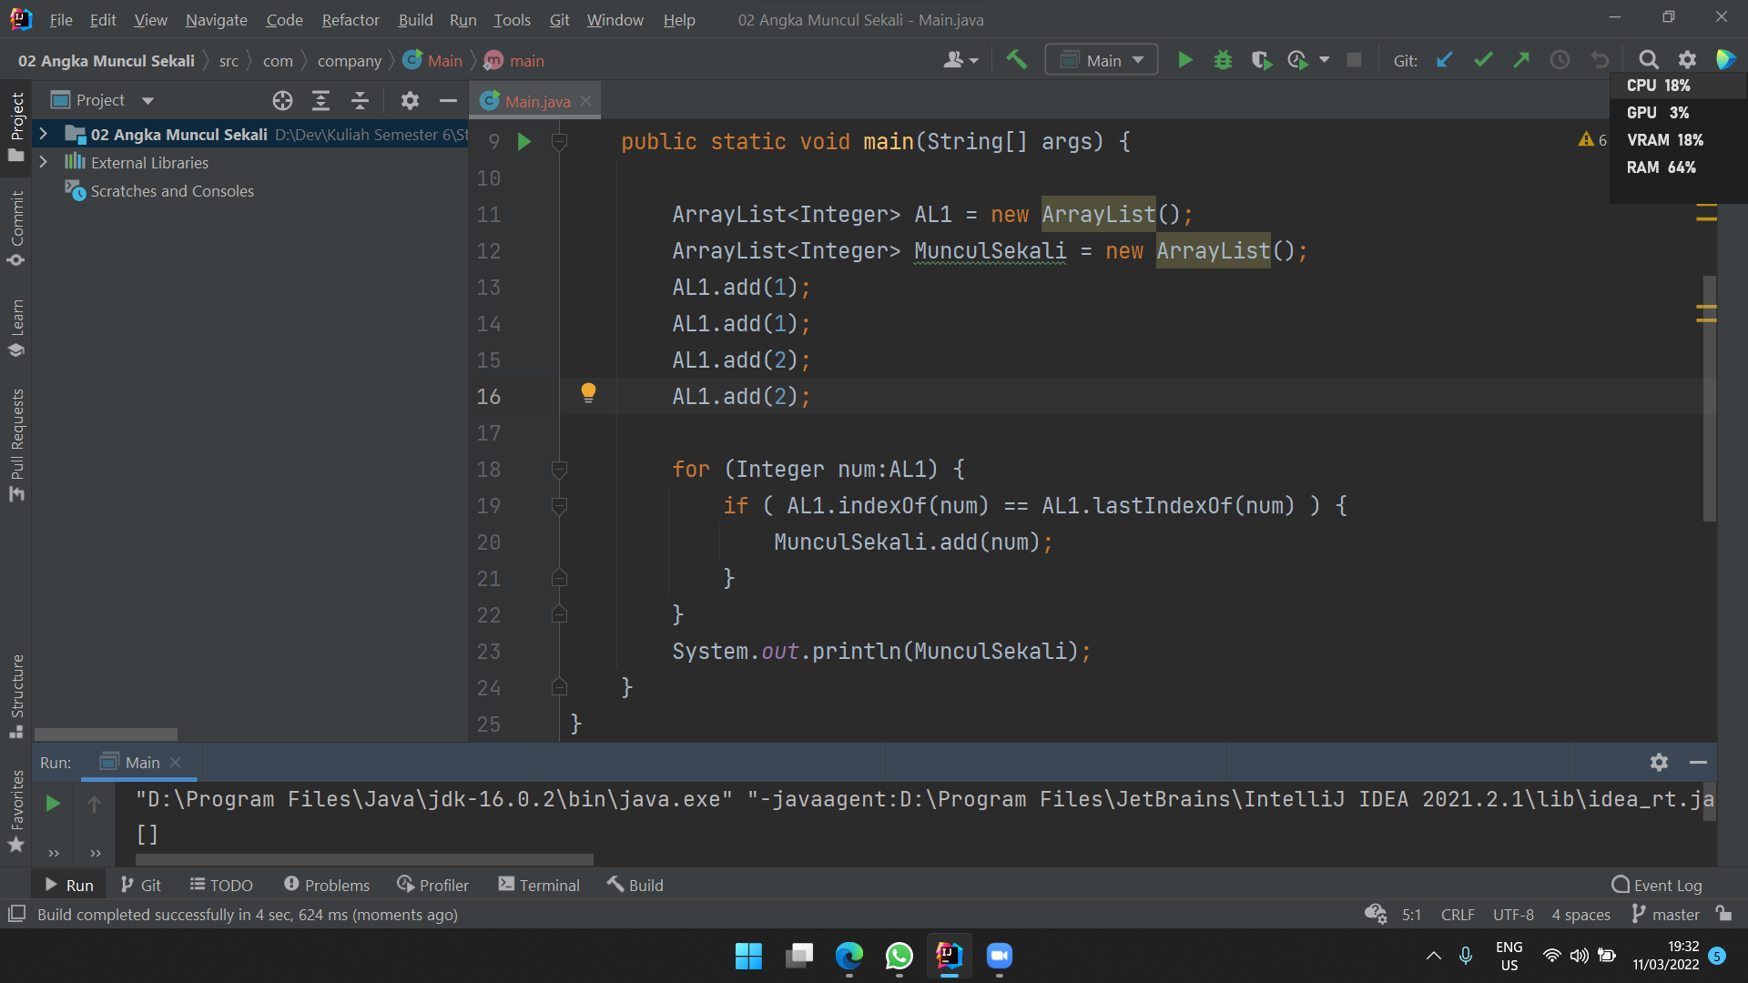

**Problem 3 - Pair with Target Sum**

Input: [1, 2, 3, 4, 6], target=6

Output: [1, 3]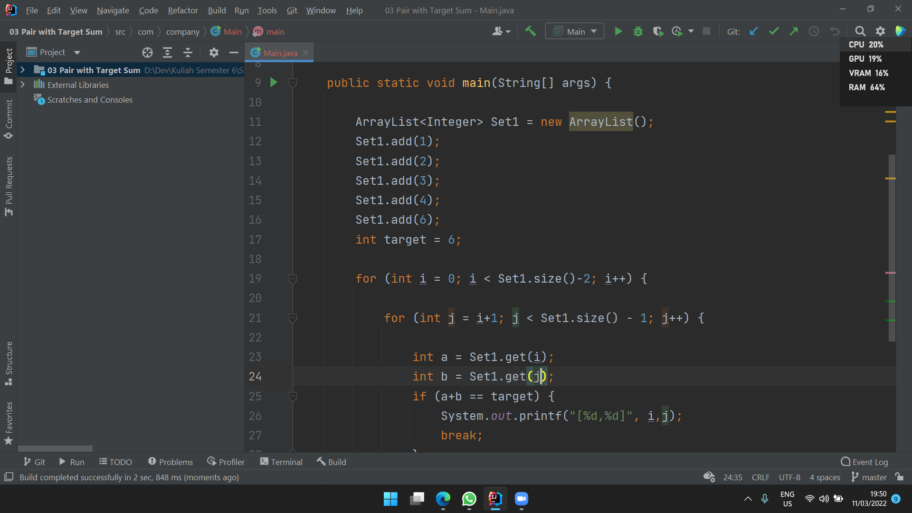

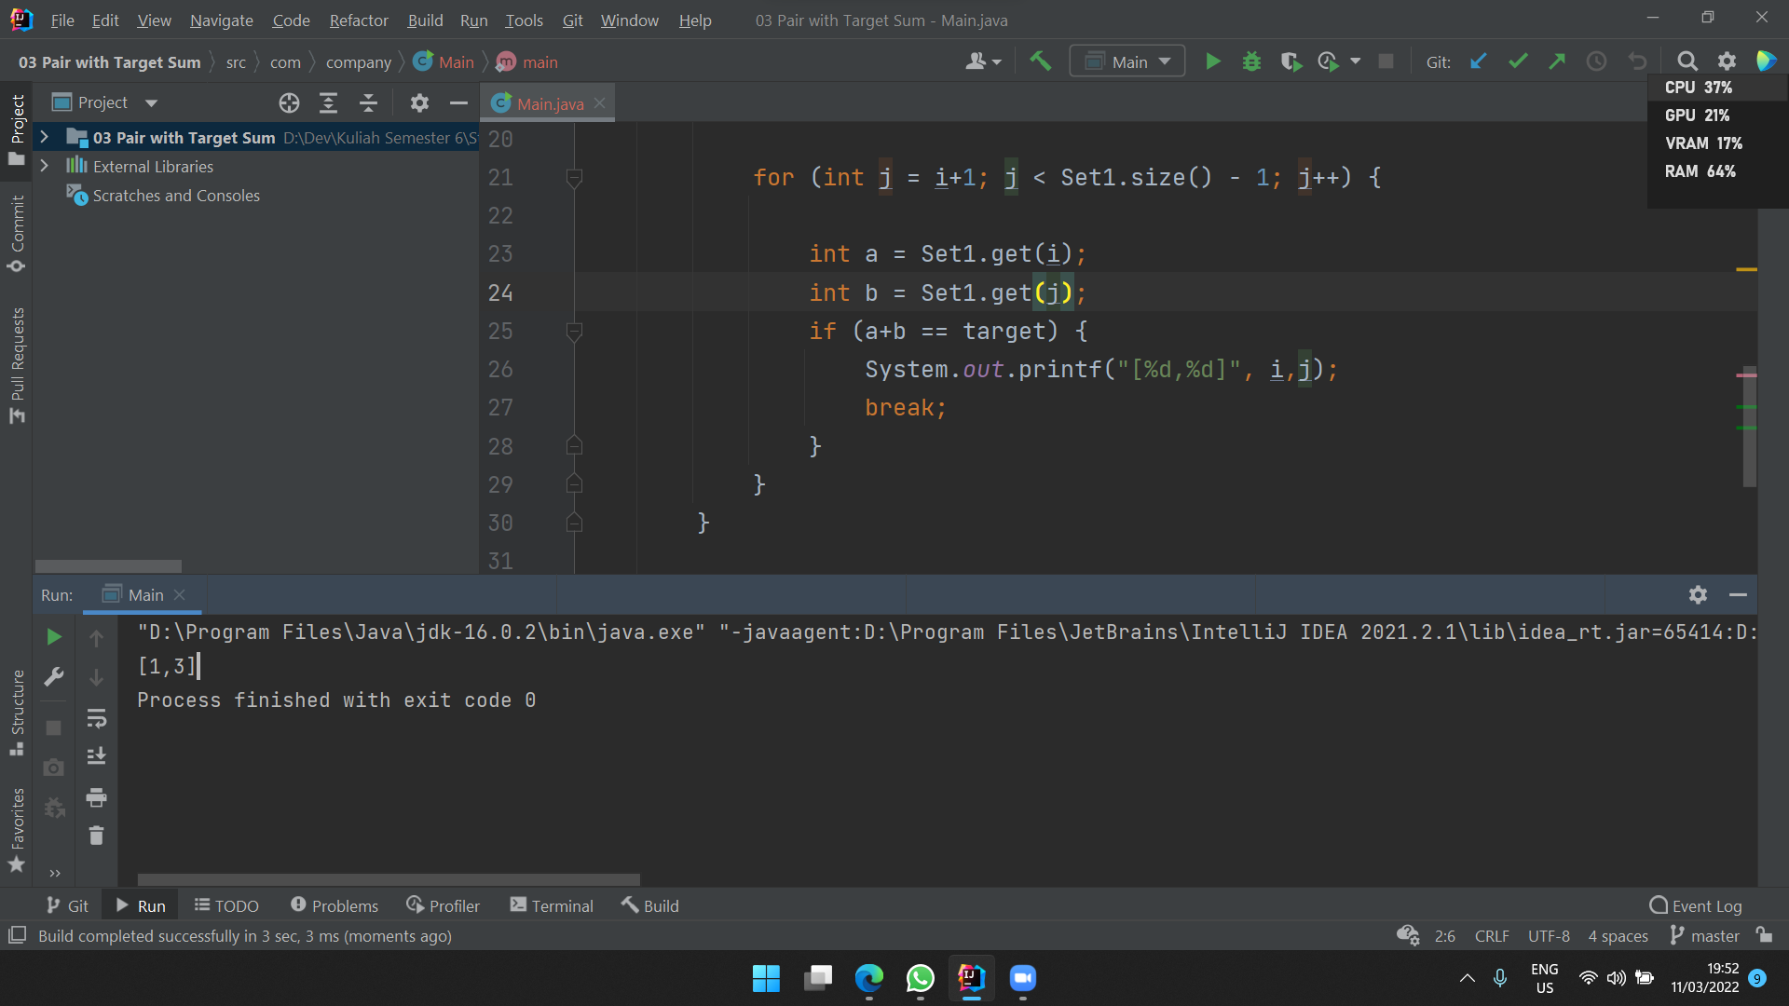

Input: [2, 5, 9, 11], target=11

Output: [0, 2]

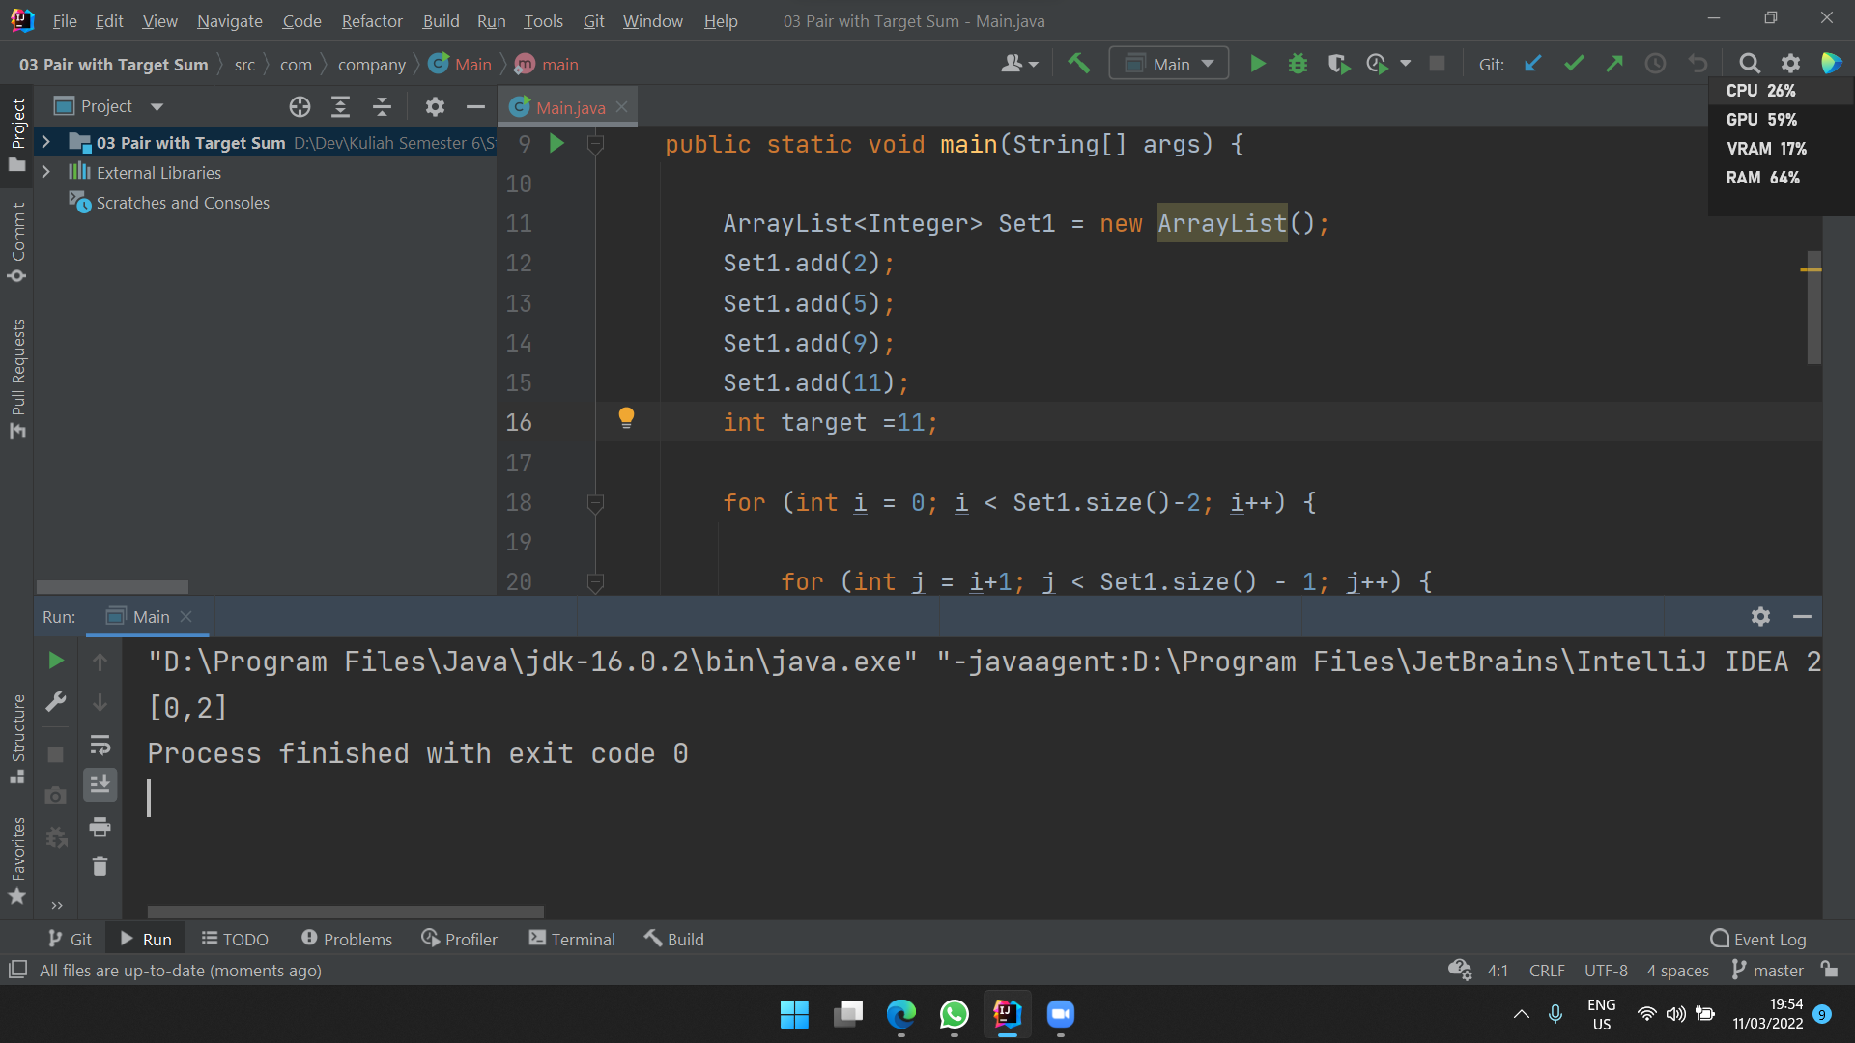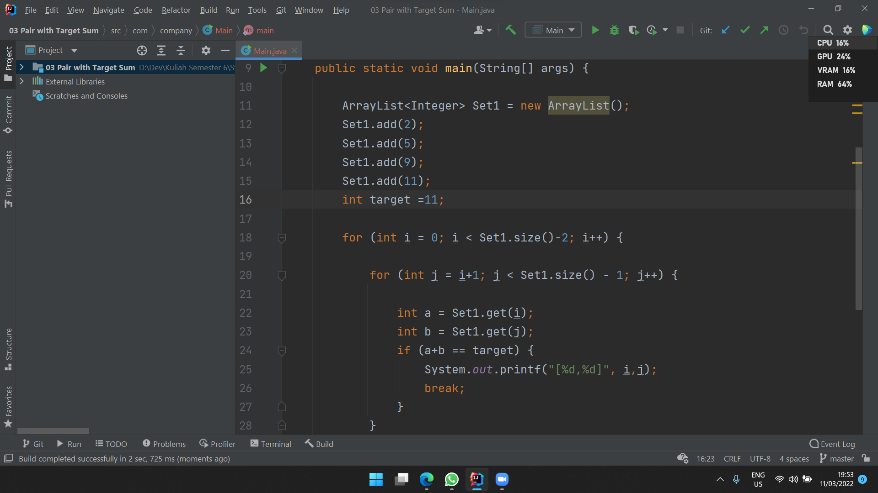

**Problem 4 - Array Unique**

input: [1, 2, 3, 4] dan [1, 3, 5, 10, 16]

output: [2, 4]

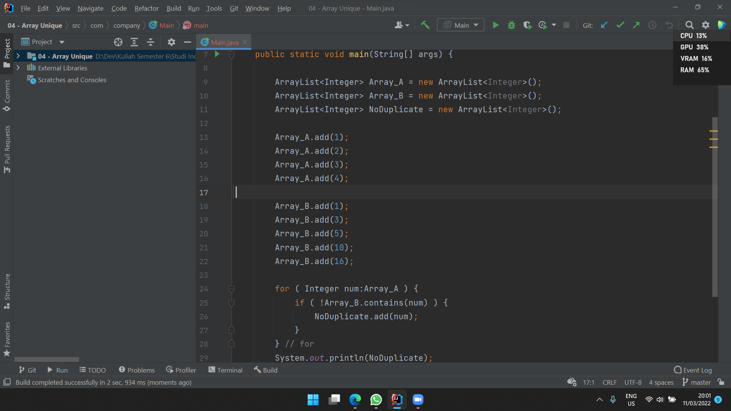

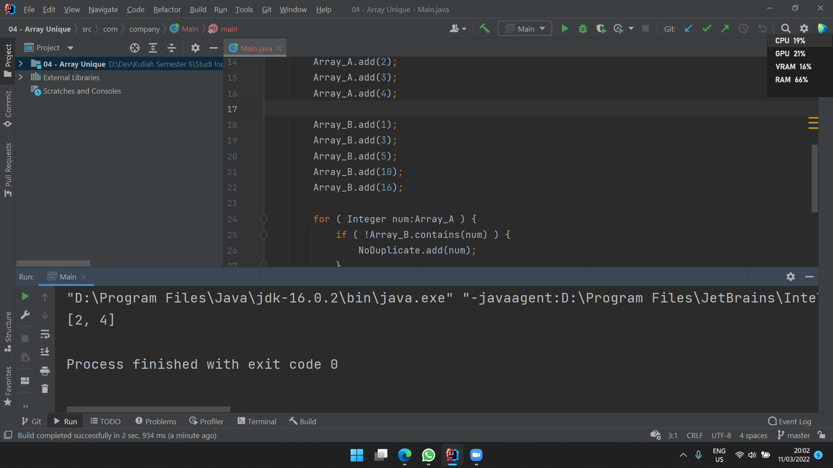

input: [3, 8] dan [2, 8]

Output: [3]

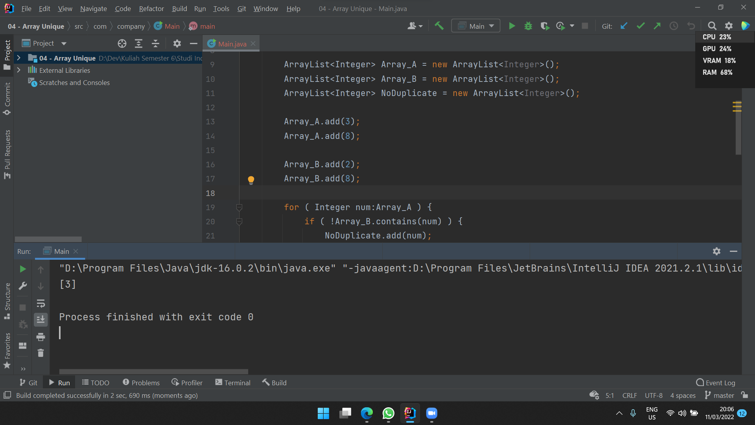

**Problem 5 - Remove Duplicates**

Input: [2, 3, 3, 3, 6, 9, 9]

Output: 4

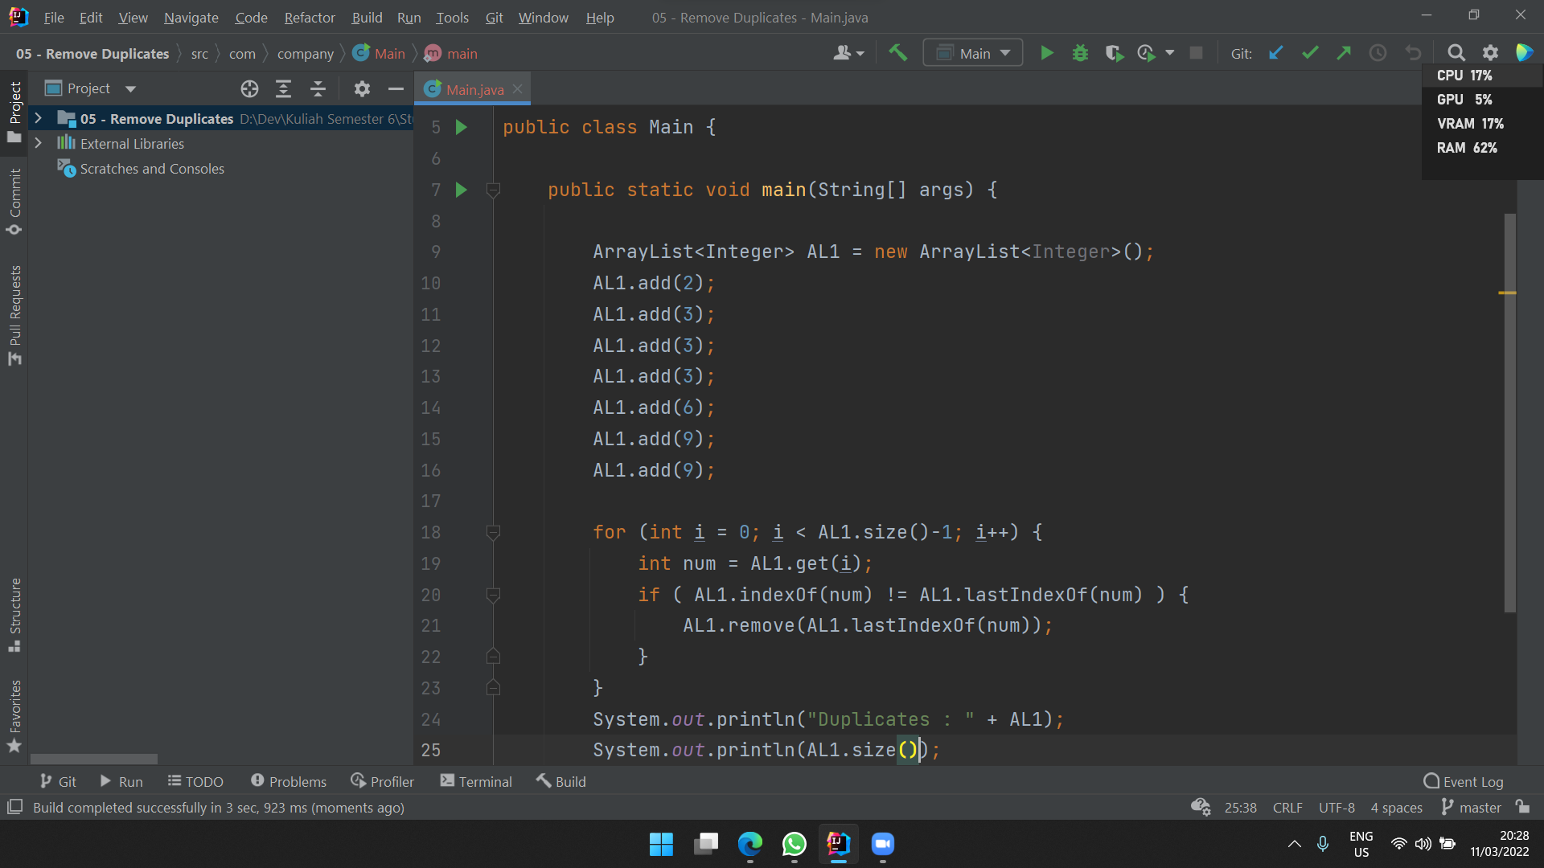

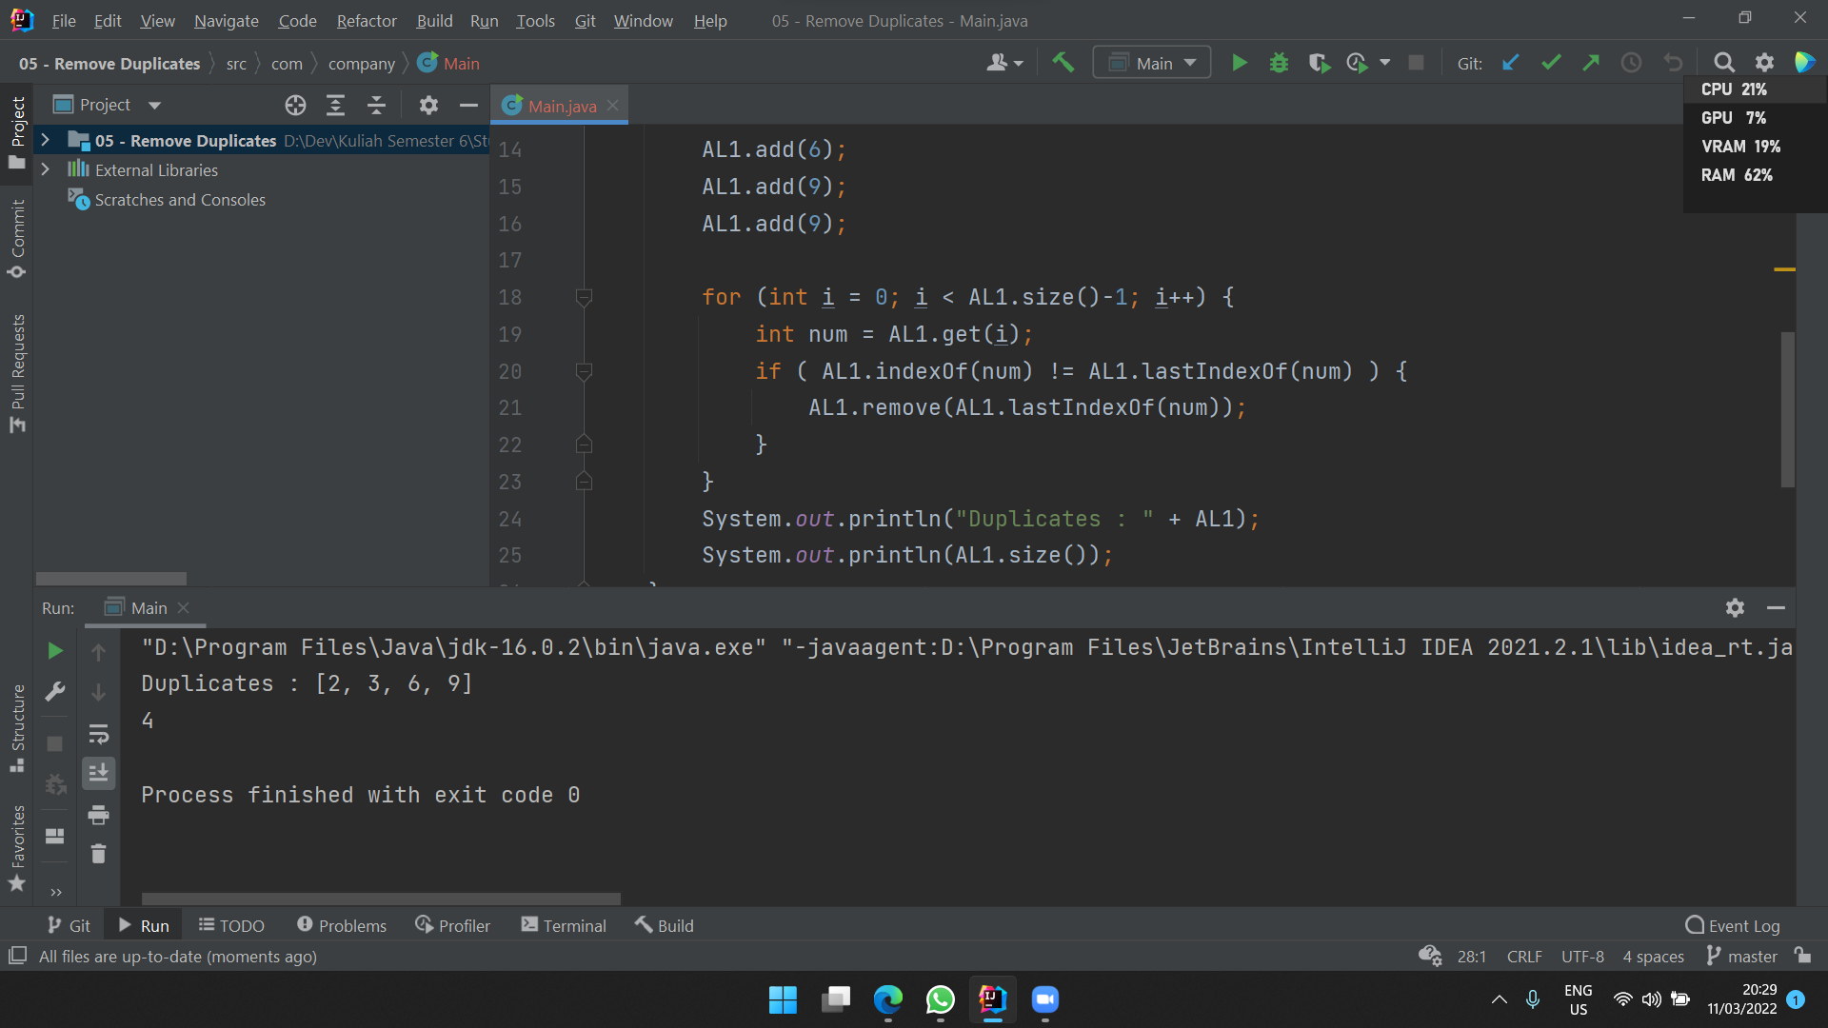

Input: [2, 2, 2, 11]

Output: 2

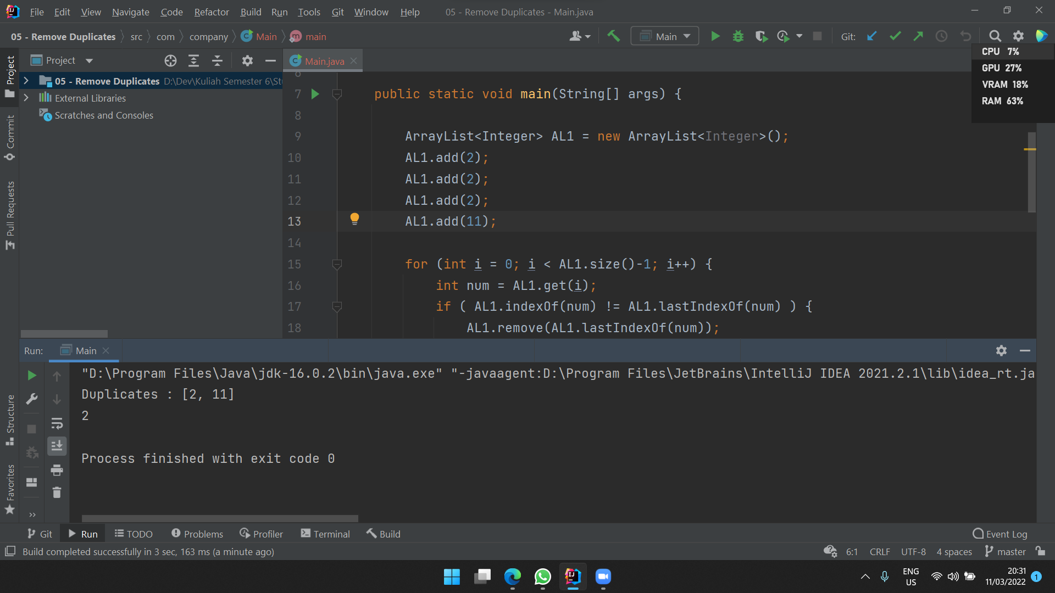

**Problem 6 - Maximum Sum Subarray of Size K (Optional / Nilai Tambah)**

Input: [2, 1, 5, 1, 3, 2], k=3

Output: 9

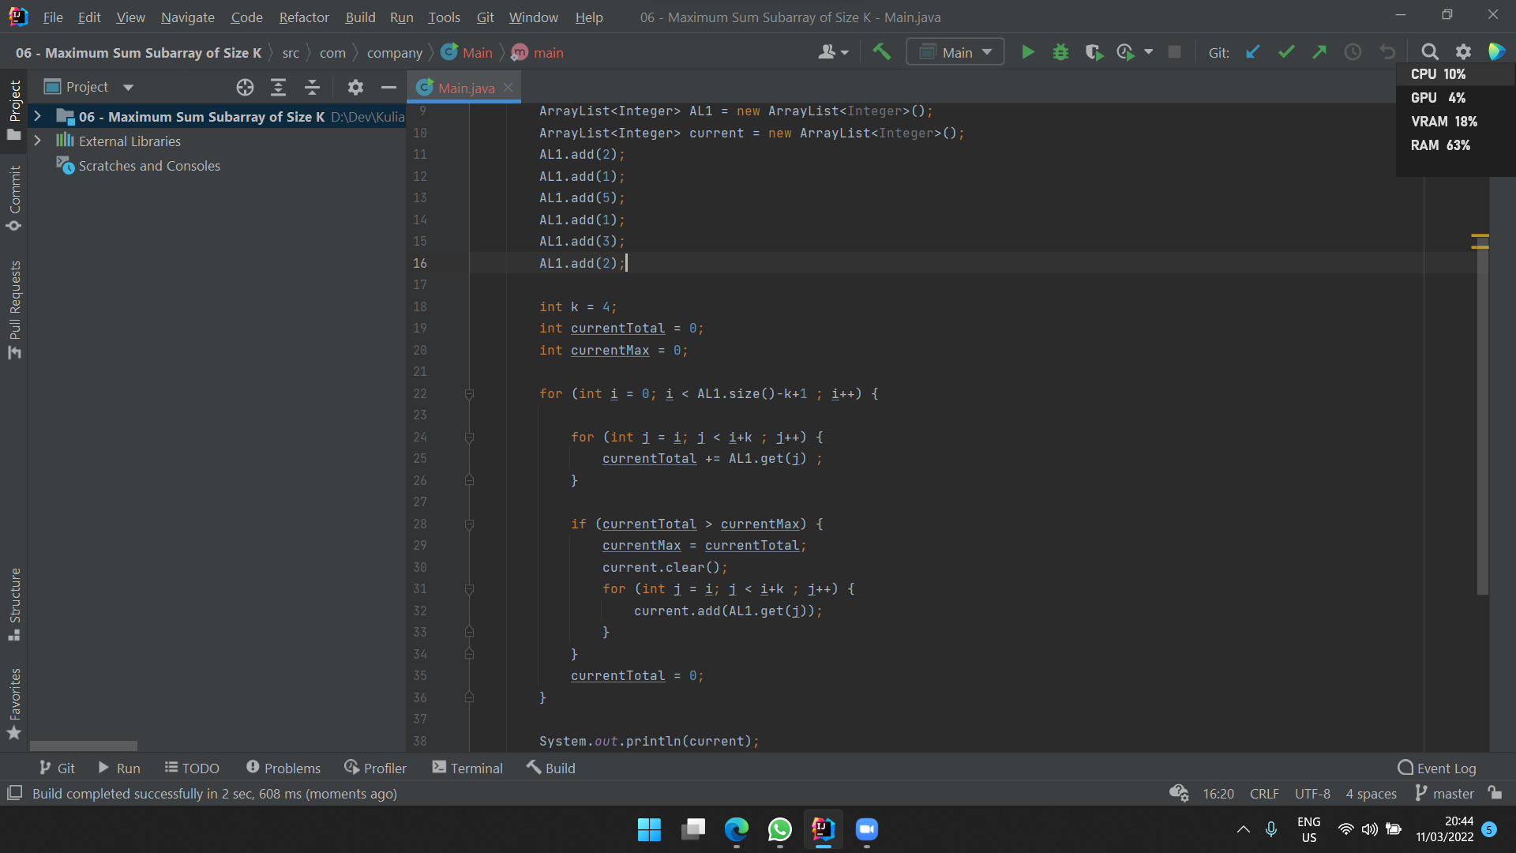

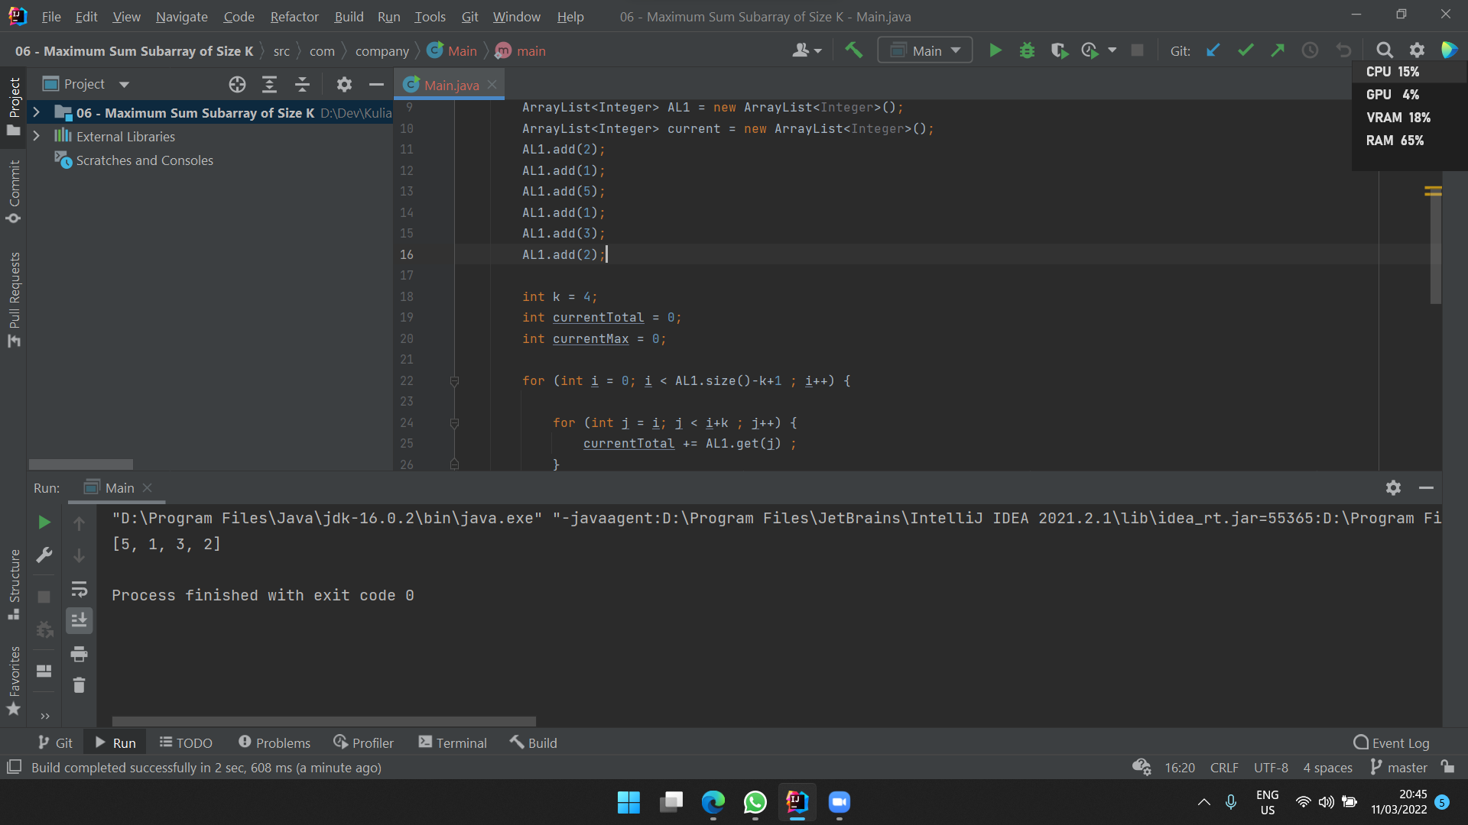

Input: [2, 3, 4, 1, 5], k=2

Output: 7

